Dear International Student,

Please be invited to join “International Student Orientation” which consists of 2 parts;

Part I : KKU Information and Services
19 August 2016 at 08.30 a.m. – 16.30 p.m., Graduate Meeting Room, 4th Floor, Bimala Kalakicha Building.

Tentative Program
08.30 - 09.30 Registration
09.00 Opening
      - Speech by Vice President for International Affairs
      - Opening Speech by KKU President
      - Group Photo
09.10 Lecturer and Staff Introduction
09.20 Graduate School Service and Presentation
09.50 Library Service
10.20 Registrar Office Service
10.40 International Relations Division Service and Presentation
      - International Relations Division Organization
      - VISA
      - Student Activity
      - Q & A
11.30 Health Insurance
12.00 Lunch
13.00 Campus and City Tour

Part II : KKU Blood: Walk Rally
27 August 2016 at 08.30 – 17.00, at Khon Kean University

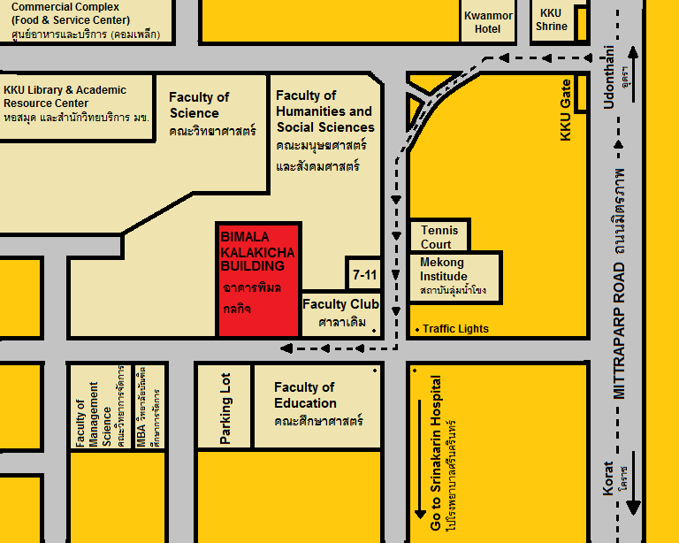

All new students MUST join this activity

